 



**Fareham College**

**Travel Plan 2014/15**

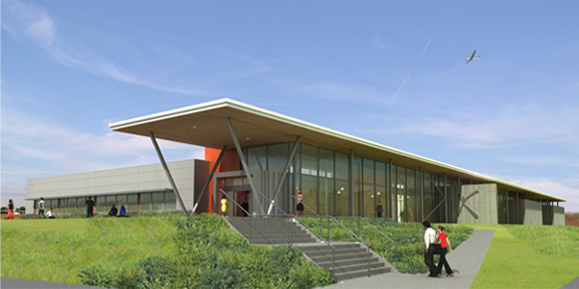

This travel plan has been developed for the educational and training facilities operated by Fareham College in conjunction with the Hampshire County Council travel plan advisors. A new campus is being constructed in the Solent Enterprise Zone at Daedalus and is due to be occupied from September 2014. The redevelopment of the existing Bishopfield Road campus commences in June 2014 and is due to complete in the summer of 2015. A transport assessment and framework travel plan for the new CEMAST site have been prepared by Jacobs. A transport assessment and framework travel plan for the main BRC site has been prepared by Stuart Michael Associates. This travel plan will build on these documents to cover all Fareham College sites in a single travel plan.

**Contents**

|  |  |
| --- | --- |
| Foreward | 1 |
| **Section 1 – Background** | 3 |
| Introduction | 3 |
| **Section 2 – Travel Plan aims and Transport Policy** | **7** |
| Transport Policy | 7 |
| National Policy | 7 |
| Local Policy | 8 |
| Staff and student survey results | 13 |
| **Section 3 – Consultation** | **17** |
| **Section 4 – Evaluation and Monitoring** | **21** |
| **Section 5 – Formal Approval of the Travel Plan** | **21** |
|  |  |
| **Appendices** |  |
| 1 Action Plan | 23 |
| 2a Proposed site plans of Fareham College Bishopsfield Road campus | 27 |
| 2b Location map of college showing local road names | 28 |
| 3 Proposed CEMAST site plans | 29 |
| 4 First Bus network map for Fareham and Gosport and surrounding area | 30 |
| 5 Cycle route map for Fareham and Gosport and surrounding area | 31 |
| 6 a and b 2013 Staff and student travel plan survey results | Excel spreadsheet |
| 7 2013 CEMAST student travel plan survey results | Excel spreadsheet |
| 8 Screen dumps of online surveys for both staff and students | 32 |
| 9 BRC exhibition board for travel (pre planning) | 33 |
| 10 BRC exhibition board for travel (post planning) | 34 |
| 11 Extract from Corporation minutes | 35 |

|  |  |
| --- | --- |
| 1 | **SECTION ONE - BACKGROUND**  **Introduction**  The overall aim of this travel plan is to encourage and enable the use of sustainable modes of travel to and from Fareham College and CEMAST, while improving the safety of all those studying, working at and visiting the College. The impact of this will be less vehicle congestion at peak times in and around both College sites, a reduction in the environmental impact of travel to and from the College and an improvement in the health and wellbeing of students and staff at the College. |
| 1.1 | Fareham College CEMAST  Bishopsfield Road Meteor Way  Fareham Lee on the Solent  Hampshire Hampshire  PO14 1NH PO13 9FU  www.fareham.ac.uk |
| 1.2 | Fareham College is a general further education college offering a broad curriculum from Foundation Level to Higher Education. Our most recent results (2012-13) place us in the top 20% of colleges in the country for success rates. The core values of the College are Respect, Innovate and Excel. These show the College’s commitment to providing its students with an experience that will enable them to fulfil and excel in their career aspirations. |
| 1.3 | In the current academic year, 2013/14, there are around 2,000 full-time students and 1,000 part-time students. The majority of students who attend are aged 16-19 but the College also supports school children from age 14-16 and provides courses for businesses and adult learners. The staff at Fareham College have a variety of work patterns, full-time, part-time and term-time only with start and finish times differing according to their position. Currently there are 177 full time staff and 75 part time staff, of these 70 are term-time only staff. |
| 1.4 | The College is open from term time Monday and Friday 0730 to 1930, Tuesday, Wednesday and Thursday 0730 to 2100; between terms 0800 to 1900 Saturdays 0900 to 1600. However, students will arrive and leave at various times of the day, on different days of the week according to the timetable for their course, meaning that congestion at peak times is reduced. |
| 1.5 | Full-time students will attend courses for three days a week, spending the other days on work experience or studying at home. Most students arrive between 8.30am and 9.30am and leave between 4.00pm and 5.00pm. The peak time for staff arriving is 8.00am to 9.00am but most leave after 5.00pm.  Fareham College has not had a travel plan but does have a wide range of initiatives in place to assist and encourage site users to travel sustainably including cycle storage, a parking permit scheme and subsidies for public transport. This document will consider current and expected travel patterns, the provision of transport facilities and look forward to how all site users and visitors can be encouraged to travel in a sustainable, healthy, safe way to and from Fareham College. |
| 1.6 | Fareham College is developing a new 4,000m2 educational facility, Centre of Excellence for Engineering, Manufacturing and Advanced Skills Training (CEMAST), which is located at the Solent Enterprise Zone. The College also secured planning permission for the remodelling and redevelopment of its existing campus at Bishopsfield Road campus in April 2014. This project commences in June 2014 and is scheduled to be complete in the summer of 2015 and will replace 19,000m2 of existing buildings with 13,000m2 of new and refurbishment facilities. A Framework Travel Plan has been produced for each of these developments and was submitted as part of an approved planning application for the new site. This document will build on the framework travel plan and become a full travel plan for all Fareham College sites. It will consider current and expected travel patterns, the provision of transport facilities and look forward to how all site users and visitors can be encouraged to travel in a sustainable, healthy, safe way to and from Fareham College. |
| 1.7 | **CEMAST**  CEMAST will be a new industry standard training facility for Fareham College. The Centre will be located within the Solent Enterprise Zone at Daedalus airfield and its position will mean the Centre will act as a gateway to the Enterprise Zone. The Solent Enterprise Zone is led by Solent Local Enterprise Partnership, the local authorities within the Partnership for Urban south Hampshire and the Homes and Communities Agency. It is one of 24 set up nationally to support local economic and employment growth. |

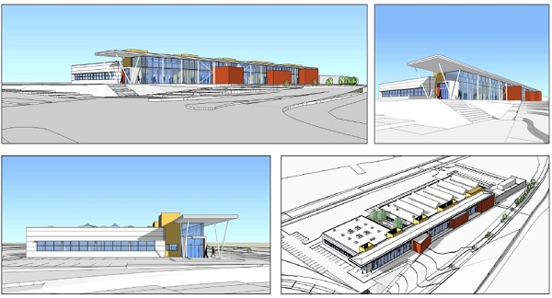

|  |  |
| --- | --- |
| 1.8 | CEMAST will provide training for approximately 400 students a day, around 900 each week. The training courses to be delivered will range from Foundation level to Higher National Diplomas and will include aeronautical, marine, electrical, automotive and mechanical engineering. Apart from marine engineering all of these courses are currently delivered by Fareham College on the existing site. Students can study on a full or part-time basis and will also be able to access apprenticeships and full cost work. There will be 35 teaching and support staff at the site, most, if not all of these staff will relocate from the campus on Bishopsfield Road. |
| 1.9 | Due to open in September 2014, the single storey building will offer open plan engineering workshops, teaching classrooms, a learning resource centre and café. There will also be conference and exhibition space to serve the local businesses community. The café will also be available to serve the Zone’s community. A plan of the proposed site is shown in appendix 3. |
| 1.10 | Improvements are also proposed to the existing junction on Broom Way/Cherque Way which will become the main access point to the Enterprise Zone. The Homes and Communities Agency submitted the planning application for this scheme at the same time Fareham College submit the CEMAST plans. It will see a fourth arm added to the junction whilst ensuring traffic continues to flow freely on Broom Way. This road is due to open in July 2014 in time for the opening of CEMAST in September 2014. |
| 1.11 | **Gosport College**  Since 2010, Fareham College has operated a partnership with Gosport Secondary Schools, Fareport Training Ltd and a number of other agencies known as Gosport College. The partnership delivers skills-based courses at a number of locations around Fareham and Gosport. The locations are not solely run by the College and include commercial premises. One of the outreach centres, Fareham Reach Campus, will be closed with the opening of the CEMAST site and completion of the BRC development. The motor vehicle courses delivered there will transfer to the Bishopsfield Road campus and the other courses will relocate to the new BRC site in September 2015. After this date the only offsite delivery point will be the small hair salon (operating as Salon 141) on Gosport High Street. |
| 1.12 | **Skills Academy**  Fareham College run two programmes for school pupils under 16, the Gifted and Talented programme and the Skills Academy. The Gifted and Talented programme offers Key Stage 4 students a vocational element to the curriculum they study for their GCSEs at school. The students have an opportunity to gain an additional Level 2 qualification alongside their GCSEs in either Accountancy, IT, Media or Performing Arts. The course runs as an extra-curricular activity one evening a week after school for two years and as such is funded by parents/carers as other after school clubs would be. The Skills Academy courses have been running since 2002 and allow students in years 10 and 11 learn practical skills associated with a range of jobs whilst gaining a vocational qualification. Subject areas include, Catering, Motor Vehicle, Marine Engineering and Sport. Courses take place at Fareham College over a two year period for 4 hours a week, schools fund these courses and are responsible for the travel arrangements (usually by minibus) between school and college. |
| 1.13 | **Corporate and community**  Fareham College also offer corporate training services directly to business. The time and place the training takes place is flexible so that the service can meet the employers needs, therefore, it may take place at the college or at the workplace. |
| 1.14 | As well as being an educational facility Fareham College also runs a number of commercial enterprises related to its vocational curriculum offer from its Bishopsfield Road campus which are open to the public. Most of these provide training opportunities for its students.   * 141 Salons offer hairdressing and beauty treatments as well as sports massage therapies. The salon is open 9.00 – 17.00 on a Monday, 9.00 – 21.00 from Tuesday to Thursday and 9.00 – 14.00 on a Friday during term time and every Saturday (except bank holiday weekends) * Avenue 141 Restaurant is a silver-service training restaurant open for lunch from 11.45 to 14.00 Monday to Friday and for evening meals from 18.30 to 21.30 on a Thursday. * Kidz Inc Ltd is an on-site day nursery open to the general public as well as College students and staff. It is run independently and open from 8.00 to 18.00 Monday to Friday. * The College has an independent, fully bonded, travel agency called On Course Travel. The agency is located in The Mall at the Bishopsfield Road campus. * The Bishopsfield Theatre is open to the public for its students’ performances. * An NHS Leg Care Clinic which is a collaboration between Fareham College Health and Social Care teams and the NHS * A fitness gym operated by the Sports team   In addition the BRC site has extensive community use and hire by local people or community groups of meeting rooms, Sports Hall, Theatre and other facilities. When the BRC development is completed there will also be a new MUGA available for community use out of College core hours. |
| 1.15 | **Existing measures**  The College already has a range of measures in place to encourage the use of sustainable travel to college and ensure the safety of all site users. However, the college recognises there are a number of issues which it hopes to address. With the occupation of CEMAST and redevelopment of the existing BRC site the College hopes to be able to reduce the size of its site. There will then be a small reduction in the capacity of available car parking (current spaces at BRC: 395, spaces planned at CEMAST: 140, spaces at BRC: 250). To avoid this leading to an increase in offsite parking the college will use this travel plan to put in place additional measures to further increase the use of sustainable travel and hence a reduction in car use prior to these changes. The reduction in spaces at BRC is proportionately greater than the planned reduction in learner numbers on this site and therefore the College has already identified and agreed with the planning authority space for a further 20 onsite parking spaces as a contingency measure should offsite parking become a problem in 2015/16. |
| 1.16 | Another concern for the College, but one which it is actively addressing, is cycle security. There have been incidents of cycle theft from the premises despite all cycle storage being covered by CCTV. The College has had a number of successful prosecutions thanks to the CCTV recordings. Students are given a presentation on cycle security as part of their induction and cycle locks can be borrowed if required. |
| 1.17 | **Locality**  Fareham College is in South Hampshire within Fareham Borough with some of its facilities located in the neighbouring boroughs of Gosport and Eastleigh. |

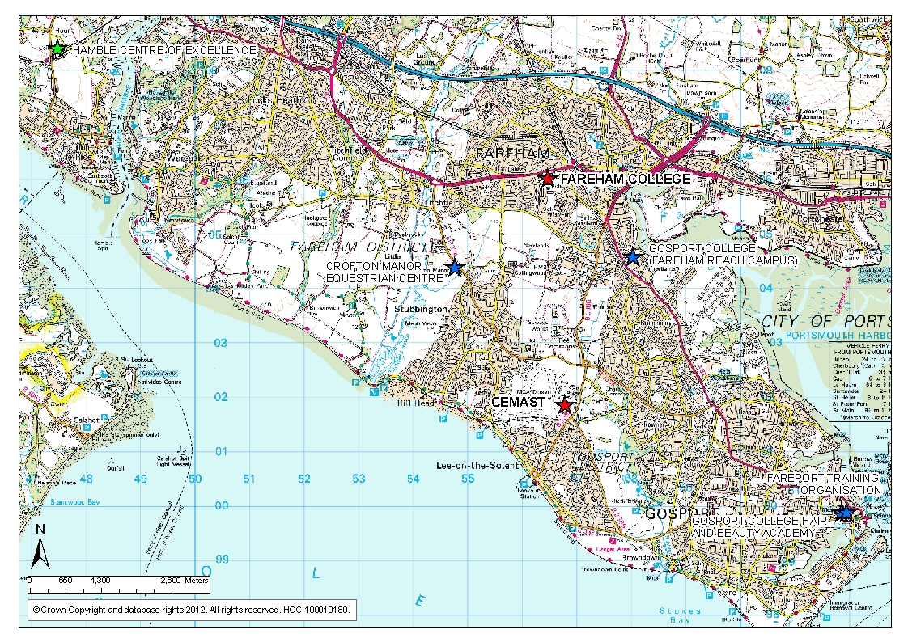

Figure 1: Fareham College campus, CEMAST and other educational facilities.

|  |  |
| --- | --- |
| 1.18 | Fareham College has its Bishopsfield Road campus located off The Avenue just to the west of Fareham’s town centre. It is within walking distance of the shopping centre, train station and bus station. The main vehicular entrance to the College is on Bishopsfield Road but the College’s northern boundary runs along the A27, a main route linking Fareham with the M27 and Southampton. The buildings on the campus are situated next to large open space and landscaped areas which will be transferred to Fareham Borough Council as a new public park in 2017. There is clear signposting throughout the campus, so the college is easy to get around and all classrooms are easy to find. As part of the BRC development a new east/west and north/south pedestrian and cycle route will be opened to aid pedestrian movement across the site and to encourage greater use of cycles. |
| 1.19 | The College is within an urban residential area and has a number of schools in the vicinity. There is a primary school located opposite the main entrance in Bishopsfield Road, an infant and junior school at the rear of the college and a secondary school to the south of these. |
| 1.20 | The CEMAST site is further south, close to the border of Gosport Borough. Being on an airfield site most of the surrounds are open countryside with agricultural land, small woodlands and a golf course. The central zone of the airfield still has an active runway. The only residential area is to the South towards Lee-on-the-Solent. |
| 2  2.1 | **SECTION 2 - TRAVEL PLAN AIMS AND ACTIONS**  The travel plan coordinator is Peter Marsh, Deputy Principal. He is supported in this role by a Working Group whose members include Gill Sommers, Director of Faculty, Steve Dingsdale, Assistant Principal, Nelson Williams, Estates Manager, Angie Hinton, HR Director, Jo Howard, Student Services Manager, Paul Brimecome, Head of Department, Engineering, Jackie Robinson, Head of Finance, Lizzie Davis, PA, Debbie Goodall, Student Finance Co-ordinator, Kellie Porter, Payroll Officer and David Evans, Lecturer |
| 2.2 | Following extensive consultation with local residents, students (including two student travel surveys), staff and both Hampshire and Fareham Councils, the College has developed a detailed Action Plan (Appendix 1). The action plan is designed to positively promote the use of public transport, to remove barriers to the use of cycles or walking, to provide financial incentives to encourage cycling and to provide appropriate incentives to encourage car sharing and modest disincentives to discourage onsite parking. The College's travel planning group will oversee the implementation of the travel action plan and report to SMT and the Corporation on its profess. The Action plan and this overall policy will be subject to formal review in the Summer of 2015 and thereafter biannually. |
| 2.3 | **National Policy**  **National Policy – National Planning Policy Framework (NPPF) March 2012**  The NPPF was published on 27 March 2012. It came into effect immediately superseding the 2011 draft and all other planning guidance (except on waste).  The National Planning Policy Framework sets out the Government’s planning policies and how these are expected to be applied. It sets out guidance and a framework within which local people and their councils can produce their own local and neighbourhood plans, which reflect the needs and priorities of their communities.  The NPPF defines the delivery of sustainable development through three roles:  1) Planning for prosperity (an economic role);  2) Planning for people (a social role); and  3) Planning for places (an environmental role).  It notes that to achieve sustainable development, these roles should be sought jointly and  simultaneously through the planning system At the heart of the NPPF is a presumption in favour of sustainable development which ‘*should be*  *seen as a golden thread running through both plan making and decision taking.*’(paragraph 14). In  paragraph 15, it goes on to say that: ‘*Policies in Local Plans should follow the approach of the*  *presumption in favour of sustainable development so that it is clear that development which is*  *sustainable can be approved without delay.’*  In the section titled “Delivering Sustainable Development” point4which promotes the use of sustainable travel it states “*Transport policies have an important role to play in facilitating sustainable development but also in contributing to wider sustainability and health objectives. Smarter use of technologies can reduce the need to travel. The transport system needs to be balanced in favour of sustainable transport modes, giving people a real choice about how they travel*.” (paragraph 29).  Paragraph 32 states that all developments that generate significant amounts of movement should  be supported by a Transport Statement or Transport Assessment. It goes on to mention that plans  and decisions should take account of whether:   * *‘The opportunities for sustainable transport modes have been taken up depending on the*   *nature and location of the site, to reduce the need for major transport infrastructure;*   * *safe and suitable access to the site can be achieved for all people; and* * *improvements can be undertaken within the transport network that cost effectively limit the significant impacts of the development. Development should only be prevented or refused on transport grounds where the residual cumulative impacts of development are severe.’*   It notes in paragraph 35, plans should protect and exploit opportunities for the use of sustainable  transport modes for the movement of goods or people. Therefore, developments should be located and designed where practical to:   * *give priority to pedestrian and cycle movements, and have access to high quality public transport facilities,* * *create safe and secure layouts which minimise conflicts between traffic and cyclists or pedestrians, avoiding street clutter and where appropriate establishing home zones,* * *incorporate facilities for charging plug-in and other ultra-low emission vehicles; and* * *consider the needs of people with disabilities by all modes of transport.*   Paragraph 36 then states “*A key tool to facilitate this will be a Travel Plan. All developments which*  *generate significant amounts of movement should be required to provide a Travel Plan*.”  This travel plan is being submitted as part of the planning application in order to demonstrate commitment to sustainable travel and ensure that sustainable and accessible development at the site is achieved. |
| 2.4 | **Local Policy**  **Hampshire County Council Local Transport Plan 2011 to 2031**  The Local Transport Plan (LTP) sets out the county’s transport strategy for the period 2011 to 2031. Its overall vision from this plan states:  “*developing and supporting stronger safer communities, maximising well being and enhancing quality of place*,” along with “*safe, efficient and reliable ways to get around a prospering and sustainable Hampshire”.*  The plan then sets out 14 policy objectives, the following objectives relate to travel planning:  **“Policy Objective 7:** Ensure that travel from home to school affordably serves changing curriculum needs, underpins sustainable schools and maximises individual opportunities for education and training;”  “**Policy Objective 11:** Reduce the need to travel through encouragement of a high-speed broadband network, supporting the local delivery of services and in urban areas the application of ‘Smarter Choices’ initiatives;”  It goes on to mention “*Smarter Choices include the range of ‘softer’ measures that aim to influence travel behaviour, and encourage people to use sustainable travel modes. Examples include workplace, residential and school travel planning, area-wide travel planning, personalised travel planning and promotion of car-sharing, for example through websites such as Hampshire’s own www.hantscarshare.com. “*  *“***Policy Objective 12:** Invest in sustainable transport measures, including walking and cycling infrastructure, principally in urban areas, to provide a healthy alternative to the car for local short journeys to work, local services or schools; and work with health authorities to ensure that transport policy supports local ambitions for health and well-being.”  On page 39, the LTP refers to “*The school run is a significant generator of traffic, and adds to congestion problems in the morning peak during term-times. Achieving greater use of sustainable travel mode journeys to school is a significant challenge. Encouraging children and young people to walk and cycle more regularly can be encouraged through Bikeability training, competitions and other measures identified through school travel plans.*”  It is hoped that this plan will play a part in meeting the objectives of the LTP and ensure sustainable travel to and from further education is improved. |
| 2.5 | **Current travel facilities and proposed travel plan measures**  Walking  The Bishopsfield Road college campus has two pedestrian access points, one in the North East corner off The Avenue and the second alongside the vehicle entrance off Bishopsfield Road. There is a third pedestrian entrance off Redlands Lane which is being brought into use in the summer of 2015.. Those walking from Fareham town centre, the residential areas to the North and East, the train station or alighting buses along The Avenue will use the first entrance and those coming from the South or West or alighting the bus at the stop on Bishopsfield Road will use the second option. Most pedestrian flow is from the direction of the town centre coming along The Avenue. |
| 2.6 | Infrastructure improvements to the access routes approaching CEMAST and the Enterprise Zone will see new footway crossing facilities. It is expected that the main route of pedestrian flow will be from Lee on Solent in the south.  The Travel Action Plan (Appendix 1) details six measures we intend to take to encourage more staff and students to walk to College. |
| 2.7 | Cycling  Provision for cyclists at the Bishopsfield Road campus includes 140 parking spaces, lockers and newly refurbished changing and shower facilities. Cycle parking is available at three locations around the site all are covered by CCTV.  CEMAST will have shower and changing facilities and secure covered cycle parking shelters to accommodate 60 bicycles, these will be for use by staff, students and visitors. The travel plan includes thirteen measures to encourage greater use of cycling including a new pay per mile cycle incentive for staff and cycle training for both staff and students. |
| 2.8 | A map showing the current and proposed cycle networks which link with Fareham College’s Bishopsfield Road campus and CEMAST can be seen in appendix 5. |
| 2.9 | The Bishopsfield Road campus has a number of on and off road routes linking the college to the local area. Not all routes have yet been formalised and there are new proposed routes including a route along The Avenue to the North of the College. These new routes will be opened up east/west and north/south through the campus in 2015/16. |
| 2.10 | Adjacent to the CEMAST site, Broom Way has an off-road cycle route along its western side. This route is a shared pedestrian footway and links with Stubbington and Lee-on-the-Solent. The proposals submitted by the Homes and Communities Agency included new cycleway facilities as well as a Toucan crossing at the junction serving the entrance to the Enterprise Zone, creating one of the most picturesque cycle routes in south Hampshire. |
| 2.11 | Public transport  Every student is entitled to buy a subsidised annual or termly bus pass, or a grant towards the cost of rail travel. Where there is evidence of extreme financial hardship, students can receive some assistance with travel costs through the College's Learner Support Fund or Hardship Fund. Every case is given individual consideration to ensure that travel costs are not an obstacle to students attending Fareham College. A Student Finance Co-ordinator is available to provide advice and details about financial support for travel. All subsidies and support provided by Fareham College will be offered to students attending CEMAST as well. Currently 85% of all students receive financial assistance with bus or train travel costs. The travel plan action plan (appendix 1) includes four measures to encourage greater use of bus services (including two new dedicated CEMAST bus routes utilising the rapid transport link) and three measures to encourage greater train use. |
| 2.12 | Car and Motorcycle Parking  Parking at the Bishopsfield Road campus is available for students, staff and visitors. There are currently 395 spaces available for cars, 15 of these are for short stay visitors or reserved parking, 19 are designated as disabled parking and there is provision for 43 motorcycles or scooters. All parking is currently provided for free but a parking permit is required. To obtain a parking permit vehicle documentation must be produced. As well as provision of disabled parking at Bishopsfield Road there is also a loading and unloading area for wheelchairs. Any specific travel requirements for those with disabilities or learning difficulties are arranged as necessary. During special events or circumstances the car park at the church across the road can be use, with prior planning and permission. |
| 2.13 | At CEMAST there will be a car parking area with approximately 140 spaces for use by staff, students and visitors, a motorcycle parking bay and designated bays for those with disabilities. The College has a fleet of 3 mini-buses, these are used for between site movements and for college trips. The travel plan includes four measures to encourage greater car sharing, three measures to discourage staff and students parking and two measures to encourage safe use of motorcycles and scooters. |
| 2.14 | Bus  The main public bus provider in the Fareham and Gosport area is First Group. With the Bishopsfield Road campus being located so close to Fareham town centre it is served directly by a number of buses and has many other routes within walking distance, Fareham bus station is only a 25 minute walk away (Figure 2). The buses which serve the bus stop outside the college are the 5/5A (Fareham to Gosport via Stubbington and Lee-on-the-Solent) and 9/9A (Fareham College to Gosport Ferry via Fareham bus station, Bridgemary, Rowner and Gosport)). The 5/5A route runs every half hour throughout the day and the 9/9A route runs approximately every 15 minutes during the peak morning period and then every half hour for the rest of the day. |

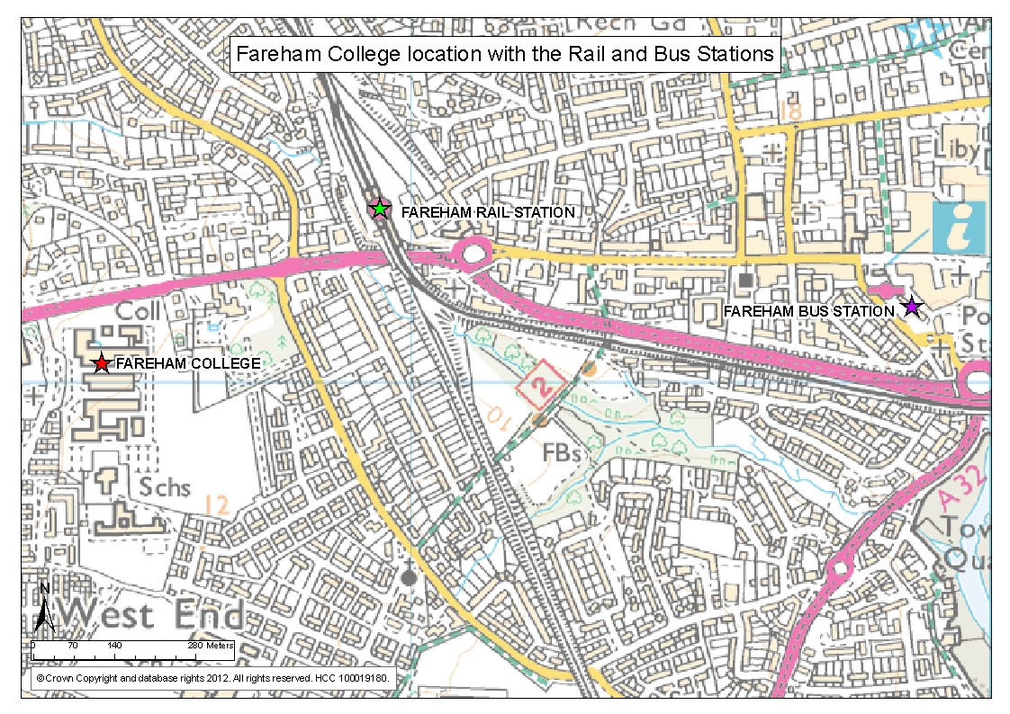

Figure 2: Map showing the location of Fareham College and the Rail and Bus Stations

|  |  |
| --- | --- |
| 2.15 | The Eclipse bus service was introduced in April 2012. The new E1 and E2 service replaced three bus routes to provide a quicker, more efficient service. The routes link Fareham bus station with Gosport Ferry via Redlands Lane. The service operates every 10 – 15 minutes and for part of its route uses a traffic-free busway. The nearest stop to the college on this route is on Redlands Lane. A passenger survey undertaken by Hampshire County Council in September 2012 at this bus stop showed that during a two hour period (8.00am – 11.00am) 168 passengers alighted the E1 and E2 services originating from Gosport. 26 passengers alighted the 87 and X88 services also originating in Gosport. It was recorded that most of these passengers were college students. The graph in figure 3 below details the time period and number of passengers alighting during half hour intervals. |



Figure 3: Graph showing the number of passengers alighting the bus services at

Redlands Lane bus stop

|  |  |
| --- | --- |
| 2.16 | A dedicated shuttle bus to and from Fareham Rail Station and Gosport ferry will be provided for use by students, staff and visitors of CEMAST. The College is contracting with First Bus Group to provide this service from September 2015. |
| 2.17 | **The Service**    It has been agreed that First Bus will provide the following service for CEMAST students and staff:-    Collection from the following points for transportation to CEMAST arriving by 0800 and 0900  Fareham Bus Station, Fareham Railway Station, Gosport Ferry Terminal.Collection from CEMAST at 1600 hrs and 1700 hrs for transportation to destinations above.  The routes to satisfy the requirements but to consider pick ups in the following areas:-   Hoeford BRT, Carisbrooke Road Shops, Peel Common Roundabout, Gosport War Memorial Hospital, Holbrook Leisure Centre, Rowner Cross Roads. Also a return shuttle service for 16 passengers running every half hour from 0900 hrs to 1600 hrscovering the following points:  CEMAST, Peel Common roundabout, Rowner Cross Roads, Fort Brockhurst. The service to run 180 days throughout the academic year between September & July. The cost of an annual bus pass for students at CEMAST or Fareham College will be £300 in 2014/15 irrespective of which bus company (First or Stage Coach) students need to use. All CEMAST or First Bus pass holders will also benefit from free Wifi on board their bus and an all zones 5 day bus pass. Fareham College is committed to supporting students in their journey to a College, 85% of students who have a bus pass receive financial support towards all or part of the cost of the pass. |
| 2.18 | A free minibus service is provided for Gosport College students in the morning. It runs from Fareham College at 8.00am arriving at Fareham Reach Unit at 8.55am. Route and timetable details are available on the College website. |
| 2.19 | Train  Fareham rail station is the closest station to both college sites. The station is about a 10 minute walk from the Bishopsfield Road campus straight along The Avenue (Figure 2) and about 3 miles from CEMAST. As mentioned a shuttle bus will be provided between the station and CEMAST. |
| 2.20 | The rail station is operated by South West Trains and the main routes from this station serve Portsmouth and Southampton and further afield destinations including London, Cardiff and Brighton. The local services to both Portsmouth and Southampton run approximately five times an hour to and from Fareham rail station |
| 2.21 | **Survey information and results**  **Student survey** |
| 2.22 | A copy of the full student and staff travel survey results is attached in appendix 6a and 6b, below is a summary of some of the key outcomes. The student response rate was 25%, with 385 students completing the survey. |
| 2.23 | * Students responded from all College sites. The majority (87.5%) were based at Bishopsfield Road. * Most students attend the College from Monday to Thursday. There is a clear peak for the morning arrival between 8.30am and 9.30am. The peak departure is 4.00pm to 5.00pm but there are also many students leaving before and 4.00pm and after 5.00pm, spreading out the traffic flow in the afternoon slightly more. * Among the survey respondents, bus is the most common mode of travel, 27.8%. Car use is quite high at 19.4%. Public transport accounts for 35.9%, considering the proximity of the college to the bus and train stations this may indicate some potential mode shift. There are 14.8% of students walking and 9.4% of students cycling. |

|  |  |
| --- | --- |
| 2.24 | * For all modes of travel convenience rates highly as a reason for that choice. Those cycling recognised the cost and health benefits of this mode of travel which could be important factors to promote to encourage more student cycling. * Convenience was the reason given by 43.4% of drivers but only 23.8% stated that distance was a reason for driving this may indicate potential for modal shift if, when promoting other modes of travel, they can be demonstrated as convenient modes too. * In the main student respondents are content with their current form of travel to College. Only train and taxi users expressed a preference for the car over their current mode. With the more sustainable forms of transport car as a preference was always rated quite highly so it is important for the travel plan measures to deter students from using the car. * Students who showed a preference for driving over their current mode of travel do not drive because of cost, not having access to a car and mainly because they cant’ drive. This may see students wanting to shift to the mode once they can drive, later in their 1st year or in their 2nd year. * The majority of students who would like to walk or cycle state distance as the main preventing factor. * If car sharing is to be promoted for students a scheme would need to be established to link potential sharers. * A lot of the respondents felt no changes were necessary to improve walking or cycling to the college. However, improved routes and storage facilities were stated by many respondents as being changes which could make the journey easier or safer. * A number of students felt cycle training would be welcomed as well as other college facilities such as lockers, showers or bikes for loan. * Over half of students stated that they didn’t receive any discounted travel on public transport. * Most students, 93.1%, park in the college car park. * When asked what would encourage students drivers to change to more sustainable travel methods over half (54.1%) of students stated cheaper public transport. Other highly rated factors which could encourage student drivers to shift to more sustainable travel include better buts frequency and routes, a car share scheme, more information on public transport and better cycle routes and facilities. |

|  |  |
| --- | --- |
| 2.25 | * The majority of additional comments made by the students were related to bus travel frequency, timetables and reliability. * Comments about walking related to safety on the route into college and within the college entrance. * Some of those commenting on train travel were quite positive about the services and grant received from the college. It was mentioned by others, however, that the college could financially support train travel for students more. * Comments about the car park mainly stated that more parking was required including for motorcycles. * A number of students responding to the travel survey in June 2013 will go on to study at CEMAST in September 2014. Only 18 students indicated how they might travel there though. Half stated that driving would be one of the modes of travel they will use. Others will cycle, use public transport, motorcycle or car share. |
| 2.26 | **Staff survey**  A copy of the full staff travel survey results is attached in appendix 6b, below is a summary of some of the key outcomes. The staff response rate was 52%, with 166 staff completing the survey. |
| 2.27 | * Staff responded from all College sites. The majority (92.8%) were based at Bishopsfield Road. Most of the respondents were support staff, 57.8%, and 42.2% were teaching staff. * Arrival at the college by staff is mainly before 9.00am. A similar number of staff work at the college each day. Departure times are slightly more spread out with around just over 10% leaving before 4.00pm, around 30% leaving between 4.00pm and 5.00pm and nearly 60% leaving after 5.00pm on most days. * Staff do work at home but this tends to be in addition to the work they do in college rather than instead of travelling in to work at the College. * Around a third of staff are interested in moving to CEMAST, most would travel there by car (63%) others would cycle, walk, use the bus or come by motorcycle. * The main mode of travel to work for staff respondents is by car, 65.9%. Other staff walk (11.4%), car share (7.4%) and cycle (6.8%). Only 6.8% use public transport (Train – 5.1% and Bus – 1.7%). Only a few staff respondents get dropped off at the College. |

|  |  |
| --- | --- |
| 2.28 | * Those travelling by car to the college including car share and getting a lift state that convenience is the main reason for this. Those who walk and cycle rate the cost and health benefits as being as or more important than the convenience. * 40% of staff driving alone to the college stated convenience as being the reason for this mode of travel but only 21% felt that living far away from the college was a reason. * Other than those travelling by bus or car sharing the majority of staff respondents travel by their preferred mode of travel. For those staff currently driving 25% state they would rather cycle, 15% would rather walk and 15% would prefer to car share. These modes of travel may not always be an option but seeing a willingness is encouraging and it will be worth the college looking further at what potential for mode shift there could be. * Staff who would rather walk and cycle don’t mainly due to distance, but another common factor preventing cycling was the lack of shower and changing facilities. * The main reasons why staff who would like to car share don’t is due to the varying start and finish times of college staff and because they do not have a car share partner. * Popular comments to encourage more staff to walk and cycle include improved cycle storage, improved cycle routes to the college and the provision of shower, changing and locker facilities. * Not many staff (11.8%) who travel by public transport purchase discounted tickets. * Nearly all staff (99.2%) who drive park in the college car park. * Staff who drive gave a range of measures which would encourage them to shift toward more sustainable travel methods. |

|  |  |
| --- | --- |
| 2.29 | Staff comments were mostly relating to cycling and driving/parking. Comments regarding cycling were focused on College facilities (showers, storage and lockers) and having a cycle to work scheme at the College. |

**SECTION 3 – CONSULTATION**

|  |  |  |  |
| --- | --- | --- | --- |
| **Group  consulted** | **On what?** | **How?** | **When?** |
| **Students** | Travel to and from Fareham College | Survey questionnaire | June 2013 |
| **Staff** | Travel to and from Fareham College | Survey questionnaire | May 2013 |
| CEMAST design proposals | Through a programme of subject based briefing meetings | Jan and Feb 2013, June 2013, October 2013, Feb 2014, Mar/Apr 2014 |
| **Governing Body** | Survey outcomes and the travel plan aims | Governors meeting agenda item | Sept 2013, June 2014 |
| **Residents** | Concerns with college travel | BRC exhibition | Sept 2013, June 2014 |
| **Fareham Borough Council Planning Department** | CEMAST planning application | Meetings | 7/1/13 and 15/2/13, Nov 2013, Spring 2013 |
| **Local Councillors** | CEMAST project and proposals for the access junction. | Public and Councillor exhibition  BRC exhibition | 6/2/13 and 7/2/13 |
| **HCA** | CEMAST design progress | Meetings | July 2013, June 2014 |
| **HCC architects department** | CEMAST and BRC design progress | Design review meetings | CEMAST10/12/12, 19/12/12 and 6/2/13  BRC May 2013, Sept 2013 |
| **Crime Prevention Design Advisor of Hampshire Constabulary** | Aspects of CEMAST site design including CCTV, external lighting and security | Meeting CEMAST  Meeting BRC | 29/1/13 |
| **Attendees of public consultation for CEMAST and BRC** | CEMAST project and proposals for the access junction. | Public exhibitions | 6/2/13, 7/2/13 and 9/2/13  Sept 2013, June 2014 |

Minutes from PSG and Travel Plan Group are available to view on request.

|  |  |
| --- | --- |
| 3.1 | Public consultation events for the CEMAST project – Around 1000 invitation letters were sent out to local residents, businesses, councillors and other stakeholders and also advertised in the local press. The first was held at Fareham College and was attended by 55 individuals, the second event was held at St Faith’s Church in Lee-on-the-Solent and was attended by 60 individuals. The final event was held in conjunction with a College open day which was attended by around 400 people, 50 of these spoke with College staff on the exhibition stand about the CEMAST project. |
| 3.2 | The following outcomes from the consultation events are stated in the CEMAST Design and Access Statement, March 2013.   * Improved skills provision strongly supported. * Traffic needs to be carefully considered, particularly impacts to the North of the site; queries over what highway improvements, if any, may be needed. * General support for the proposals. * Pleased with proposed design. * Proposals will kick-start development and regeneration of wider site. * Pleased to see a College at the site and believe this will link in well with proposed employment uses. * Public transport provision needs to be considered. * Early delivery to be commended. |
| 3.3 | A pre-planning consultation exhibition for the BRC development was held in September 2013 |
| 3.4 | Following Fareham Borough Council’s agreement to the approach, a public exhibition of the proposals for redevelopment at the BRC site was held at the College from 16 September 2013 to 11 October 2013. Presentation boards provided details of the proposed College redevelopment as well as a 3D fly around movie. The display included outline details of the proposed residential development. The exhibition was announced in the local press and letters of invitation were sent to local residents. Members of the project were in attendance on 16 September to explain the proposals and answer questions. A private preview was also held for councillors and key stake holders. Responses were sought via a feedback form. |
| 3.5 | The principal issues raised by stakeholders on the feedback forms provided during the public exhibition and by email are summarised in Table 1, below. |

|  |  |
| --- | --- |
| Issue raised | Applicant’s response |
| The proposals will raise the profile of Fareham College and will generate employment. | Fareham College will seek to maximise opportunities to raise the profile of the College and to generate employment. |
| A gate should be provided to allow pedestrian access from the new dwellings to Wallisdean Infant and  Junior Schools, reducing car use during peak times. | A footpath link to a new opening is proposed from the new housing area to Wallisdean Infant and Junior Schools. |
| The proposals may affect the water table and site drainage, particularly in the southern part of the site. | A Drainage Assessment has been completed. The recommendations of the Assessment will be implemented by Fareham College and the  residential developer. |
| The pedestrian and cycle link from Bishopsfield Road to Redlands Lane should be secured in perpetuity. | The pedestrian and cycle link will be secured through inclusion within the description of development, or the Section 106 Agreement. |
| The proposed public open space is supported, subject to the implementation of measures to control antisocial behaviour. | The public open space is proposed to be transferred into the ownership of Fareham Borough Council. The Council will manage  the open space in accordance with the standards set out within Fareham Open Space SPD to ensure that the open space is safely accessible and available to the general public. |
| Greenfield development may affect local residents’ visual amenity. The general consensus was that the  residential development should not  extend any further into the greenfield area of the site. Some of the residents of Wallisdean Avenue supported the proposals for houses  on the greenfield part of the site, which provide natural surveillance of the public open space. | There are significant tree belts to the rear of the properties fronting Wallisdean Avenue and Westley Grove, which help to protect visual amenity. These trees will be retained where possible. The residential development will not extend any further into the greenfield area of the site. |
| Measures should be implemented to control noise and dust during demoProplition and construction. | The Leadbitter Group has been instructed by Fareham College to complete the demolition and construction of the education buildings.  Leadbitter will comply with the relevant standards to ensure that construction practices are clean, respectful and safe. |

|  |  |
| --- | --- |
| Residents support housing development to meet local need. However, some residents consider  that local housing need will be met by the new Welborne community to the north of Fareham. Residential  development at Fareham College  should be limited to 120 dwellings. | Core Strategy Policy CS2 sets out the strategic housing requirement for the Fareham Borough, outside of the new  community north of Fareham. Fareham  Borough Council has identified a balance of  1,453 dwellings to be delivered during the remaining part of the plan period (2012-  2026). The development of 120 dwellings at  Fareham College will support the Council in meeting the identified housing need. |
| Local schools may not have capacity to accommodate the additional pupils from the residential development. | Wallisdean Infant and Junior Schools have confirmed that they have significant spare capacity to accommodate the additional pupils from the residential scheme. A letter from the Headteacher of Wallisdean Junior  School supporting the proposed development is provided at Appendix H. |
| The nursery should be retained or replaced. | Fareham College is working with KidzInc to identify potential alternative sites for the nursery. Discussions have already taken  place with Wallisdean Infants School to  explore moving the nursery onto the school site which Governors of both organisations are keen to explore further. Fareham College guarantees that the nursery will remain open on the existing site until Summer 2015 which provides sufficient time to develop proposals for continuation of nursery provision on an alternative site. |
| Adequate parking should be provided within the Fareham College site to discourage students from parking on local roads. | The relocation of the engineering faculty to CEMAST will result in a reduced requirement for parking. The education proposals include  220 parking spaces. The College is working with Hampshire County Council to produce a Travel Plan which will encourage students to travel by sustainable modes. Parking on the roads surrounding the College will be monitored. |
| Visitor parking should be provided for the homes and for the public open space. | The residential scheme will include parking in accordance with Fareham Borough Council’s relevant standards. |
| Traffic is congested at peak times on Bishopsfield Road and on The Avenue, particularly at the junction. | A Transport Assessment has been  completed, which considers the impact of the proposed development on Bishopsfield Road, on The Avenue and at the junction. The signal timings at the junction are currently being reviewed with Hampshire County Council. Junction improvements will be implemented by Hampshire County Council. |

|  |  |
| --- | --- |
| Vehicular access onto Redlands Lane and Wallisdean Avenue should be avoided. A single access onto  Bishopsfield Road may not be sufficient to accommodate the proposed number of units. The access may be too close to the College access. | The scheme does not include vehicular access onto Redlands Lane or Wallisdean Avenue. Hampshire County Council has confirmed that the access onto Bishopsfield Road can accommodate 120 dwellings and is suitably located in relation to the College access. |
| A pedestrian crossing should be provided on Bishopsfield Road. | The College has agreed to fund the provision of a Pelican Crossing on the Bishopsfield  Road by means of a Section 106 Agreement. |
| The rear vehicular access to 1A and  1B Bishopsfield Road should be retained. The access should be sited to protect the amenity of adjacent properties. | The amended illustrative residential layout and site access details include a rear vehicular access to 1A and 1B Bishopsfield  Road. A buffer is provided between the  access and adjacent properties. |
| The trees along the southern and eastern perimeters of the site should be retained and managed. | The trees along the southern and eastern perimeters of the site will be retained where possible. An arboricultural assessment of the  trees within the site boundary has been completed. The assessment includes management recommendations which will be implemented by Fareham College. The trees will be managed by Fareham Borough  Council following the transfer of the public open space into the Council’s ownership. |
| The proposals should include measures to protect the site ecology. | A Phase 1 habitat survey and Phase 2 surveys for great crested newts, bats, reptiles and wading birds have been  undertaken. The proposed development  takes account of the recommended mitigation and enhancement measures. |

|  |  |
| --- | --- |
| 4 | **SECTION 4 – EVALUATION AND MONITORING** |
| 4.1 | A post scheme evaluation will be carried out after three months (ie in January 2015) of the occupation of CEMAST, this will allow the College to identify if any further measures are required to ensure the success of the travel plan in relation to this site. Within a year of completion of the works at BRC the College will review the travel plan (unless any issue arises before this in which case the travel plan will be reviewed at that point). |
| 4.2 | A subsequent travel survey will then take place in February 2016 (three years on from the most recent survey). This survey will then be used to inform and review the travel plan in March/April 2016. This review will evaluate the objectives, targets and measures of the travel plan and consider where adjustments are needed to continue working toward the aim of the travel plan. Following this the travel survey will be carried out every two years with the travel plan then being updated to take into consideration any changes in the modal split of those travelling to the College and to build on the successes already achieved. |
| 4.3 | The Deputy Principal will be responsible for carrying out future travel surveys and reviewing the travel plan. The travel plan working group will support the Deputy Principal in this task. |
| 4.4 | During the implementation of any measure should a barrier exist, where possible, appropriate action will be taken to overcome it. Potential barriers which may impede implementing certain measures or initiatives include:   * Lack of available funding. Fareham College is committed to funding measures within this travel plan, however, should budget cuts or unforeseen expenditure in other areas of the College budget mean that funds are not available for some part of the travel plan lower cost measures or fund raising activities will be considered in order to achieve the targets. In this case the College would also focus the available funds on the higher priority measures. * External organisations withdraw their support/service. Fareham College would look for alternative organisations who could provide a similar service. * Internal personnel or external groups oppose measures. In this case discussions would take place with that group to either allay their concerns or to consider an alternative method of achieving the target. The College would also consider asking experts from organisations such as the Borough or County Council to give their advice and expertise on the benefits of the measure. * Local or national incident affects public outlook (for example an accident which raises concerns over the safety of a particular form of transport). If this should occur the College would take a number of steps to ensure it did not have a negative impact on the travel plan. These steps would include ensuring the correct facts of the situation are made available so that the incident is seen in context, making sure those affected have the opportunity to discuss their concerns and try to reassure them, implementing any additional measures to ensure the safety of students and staff. |
| 4.5 | We will promote this travel plan via:   * The Travel Plan working group which includes representatives from HR, Finance, Student Services, Curriculum and general staff * The College’s internal communication channels such as Phoenix and the staff meetings * The College’s website * A dedicated Termly Travel Plan Newsletter * A termly supplement to the existing student tutorial bulletin * Student Board * Staff Liaison Group * The College’s prospectus.   The Action plan contains a range of measures which are intended to help us achieve the targets set out below:  Reduce staff parking by 20 spaces or 10% over both sites by July 2016  10 people to purchase a new bike under the salary sacrifice scheme by April 2015  20 people cycle to work regularly using the pay to cycle reward scheme by June 2015  600 bus passes issued to students each year by January 2015  Increase the number of staff sharing cars to 30 by July 2016  We will conduct annual surveys in the summer term to measure the impact of the plan with both staff and students. |
| 5 | **SECTION 5 – FORMAL APPROVAL OF THE PLAN** |
| 5.1 | The principles detailed in this travel plan for Fareham College and CEMAST are endorsed by the College Senior Management Team and Governing Body. The action plan was approved by SMT and the College’s Property Strategy Group in April 2014. The full document is subject to approval by the full Board in July 2014. |
| 5.2 | We understand that the travel plan needs to be evaluated and monitored on a regular basis to ensure that it continues to reflect the current situation. We are also aware that although we have outlined measures in our action plan, Hampshire County Council and Fareham Borough Council are not obliged or committed to fund all or any of these. |

5.3

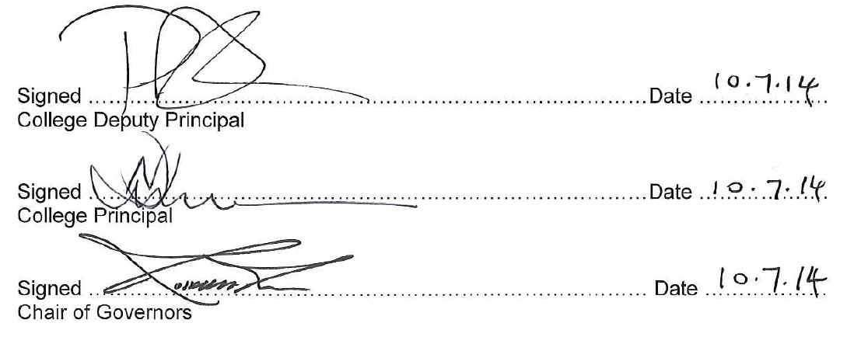

**Fareham College & CEMAST Travel Plan**

**Measures and Initiatives to promote the use of Public Transport, Cycling, Walking and Car Sharing**

**Appendix one**

|  | **Travel Plan Measure** | **Owner of Action** | **Timescale for Implementation and Target** | **Costs of Delivery** |
| --- | --- | --- | --- | --- |
| **1** | **To increase walking** | | | |
| 1.1 | Personal route planning for all new staff and students living within 2 miles of one of our College sites. Map of local walking routes showing crossing points and footpaths near BRC and CEMAST, and direction to websites. | Director of Student Services and SSM via the induction and tutorial process and SS Roadshows | September 2014 | No additional costs |
| 1.2 | Walking awareness and challenge days, eg use of pedometers for 10,000 steps challenge each Spring. Promote health benefits of walking through HR and team meetings. Linked to the welfare plan (sponsored walks, links to sports department and social committee). | HR & Student Services Managers jointly | March 2015 | No additional costs |
| 1.3 | Set expectation that staff living with 1 mile of College will walk or cycle. Parking permits to be issued to this staff group by exception only (childcare and mobility issues etc). | Deputy Principal & ED HR via SM/JCNC and Staff Liaison Group | September 2014 | Nil |
| 1.4 | Subsidise reflective or fluorescent clothing/accessories (walking and cycling) and promote safe walking practices – linked to the welfare plan. | Estates Manager and HR | September and January annual events starting 2014 | £500 budget allowance *from car parking charges* |
| **2** | **To increase cycling** | | | |
| 2.1 | Provide covered cycle storage with secure anchor points in appropriate locations near changing facilities at BRC and close to the public cycle route at CEMAST. Provide limited access to personal secured cycle lockers for high value cycles on a rental basis at BRC. | Deputy Principal & Contractor | CEMAST by June 2014  BRC by September 2015 | Included in contract sum – estimated at £30,000 |
| 2.2 | Cycle to work salary sacrifice scheme for staff to provide interest free bike loans | Head of Finance | April 2015. Target – 10 people to take up the scheme. | Consult JCNC regarding the loan limit for staff (£500) |
| 2.3 | Pay per mile cycle incentive scheme for staff to reward staff who don't take a parking permit and regularly cycle to work - pilot for one term initially. Pay 20p a mile via a claim form. | ED HR via SM/JCNC and Staff Liaison group | September 2014. Target 20 people to regularly cycle to work. | £5,000 annual budget – *from car parking charges* |
| 2.4 | Provide access to shower and changing facilities at BRC (gym, sports hall) and CEMAST concourse and promote these to staff. | Deputy Principal & Contractor and Estates Manager | CEMAST by June 2014  BRC by September 2015 | Included in capital contract sums |
| 2.5 | Promote bike maintenance help/workshops and cycling proficiency/road safety as part of Freshers Week. Awareness of courses such as IMI bike maintenance. | Student Services Manager | March 2015 and annually thereafter | Enrichment activity with no additional direct costs |
| 2.6 | Promote cycle routes and cycle zones displaying time it takes to reach destination – advertise links to <http://www.myjourneyhampshire.com/> | Marketing Team | June 2014 | None |
| 2.8 | FC staff and student discounts to be agreed with local cycle shops (10% via Solent Cycles) | Student Services Manager | February 2015 | None |
| 2.9 | Promote health benefits of cycling through HR, induction and poster awareness campaign | ED HR | Termly activity | From Wellbeing budget |
| **3** | **To increase bus use** | | | |
| 3.1 | Continue to provide access to subsidized bus passes for students (85% take up last year) | Director of Student Services and Student Finance Co-ordinator | September 2014. Target – 600 bus passes issued to students. | £200,000 (TBC) |
| 3.2 | Make bus route maps and timetables available via links to websites eg <http://www.myjourneyhampshire.com/> | Marketing Team | June 2014 | Nil |
| 3.3 | College run subsidised bus service to/from Fareham bus/train station to CEMAST and from Gosport water front to CEMAST with onward travel to BRC and provide shuttle service from Fort Brockhurst bus interchange (throughout the day) | Deputy Principal / Assistant Principal and Estates Manager / Student Finance Co-ordinator | May 2014 for September 2014 | £100,000 per annum (included above) |
| 3.4 | Provide shuttle service e.g. to Fareham Reach and from CEMAST to Rapid Transport System | Estates Manager | September 2014 |  |
| **4** | **To increase train use** | | | |
| 4.1 | *Provide loan schemes for season tickets for staff via season ticket loans and via monthly grant scheme towards the cost for students.*  Continue to provide access to subsidized train passes for students (up to £250) | HR | September 2014 | Consult with JCNC regarding possible loan scheme for train season tickets for staff. |
| 4.2 | Make timetables and route information available ensuring it is kept up to date on our website | Marketing Team | June 2014 | Nil |
| **5** | **To increase car sharing** | | | |
| 5.1 | Promote Hantscarshare car sharing scheme | ED Human Resource | September 2014. Target – to increase car shares to 30. | Nil |
| **6** | **To decrease single occupancy car use and car use overall** | | | |
| 6.1 | Promote no car days linked in to national events such as Car Free Day (22 September each year) | ED HR | Annually | From Wellbeing budget |
| 6.2 | Publicise and promote sustainable travel through this Travel Plan | DP & ED HR | Termly activity | From Wellbeing budget |
| 6.3 | Charge for car parking permits at an annual charge of 0.3% of salary (equivalent to £120 a year for a member of staff earning £40,000)with zoned parking areas for, disabled and general parking.   * Student and staff permits of different colours. * Stickered windscreens for non-compliance (TBC). Daytime only – no permit required for students whose lesson starts after 5.30. * Policing to begin on 1 October 2014. * No charge for student permit or for motorcycles (to be reviewed in light of demand for 14/15). * Students – administered by Student Services – issued from Main Reception at enrolment * Staff – administered by HR as a monthly deduction from salary (part of induction for new staff). Issued en masse to existing staff. * No parking permit for those staff who live within 1 mile of the premises (exemptions for blue badge holders and childcare provision). Appeal process to DP.   (operational details contained within Travel Group minutes) | DP, EDHR, SSM, Estates Manager and HR | September 2014 at CEMAST AND BRC  Target – reduce staff parking by 20 spaces or 10% over all sites | Estimated income £6,500 to be used to fund staff related travel measures above  Consult with JCNC regarding cost. |
| **7** | **Motorcycles and mopeds** | | | |
| 7.1 | Promote Hampshire Fire and Rescue’s RideSMART and RideSMALL campaigns | Estates Manager | September 2014 at CEMAST and BRC |  |

**Appendix 2a**

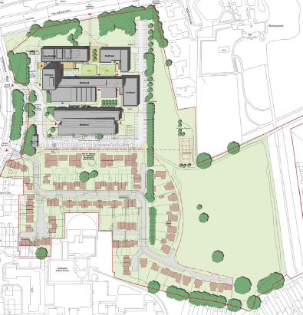

**Appendix 2b**

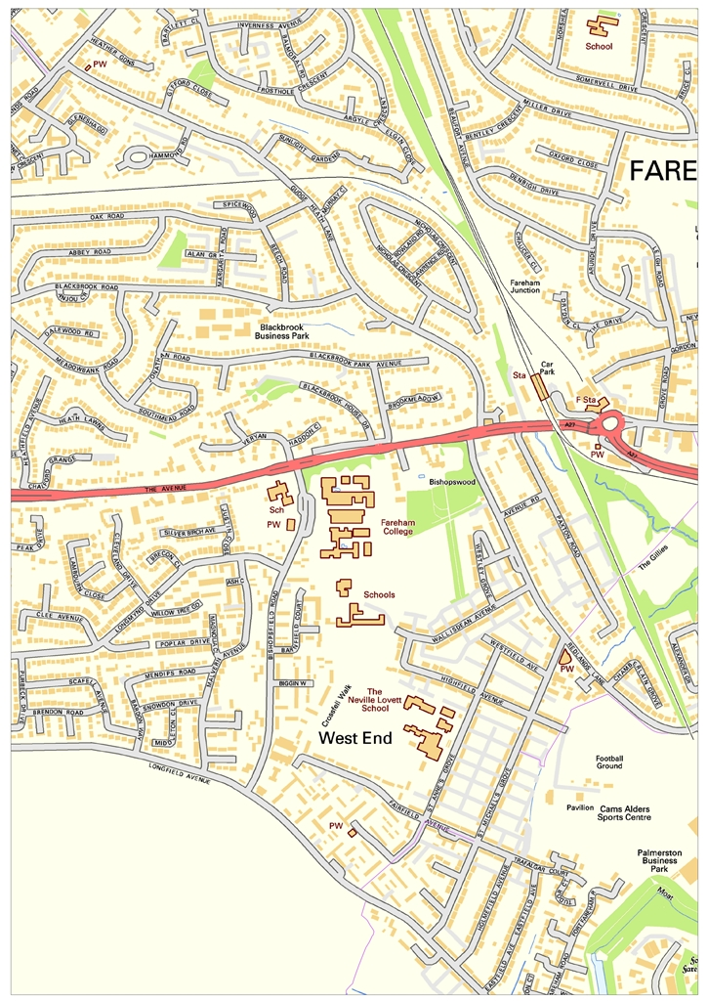

**Appendix 3**

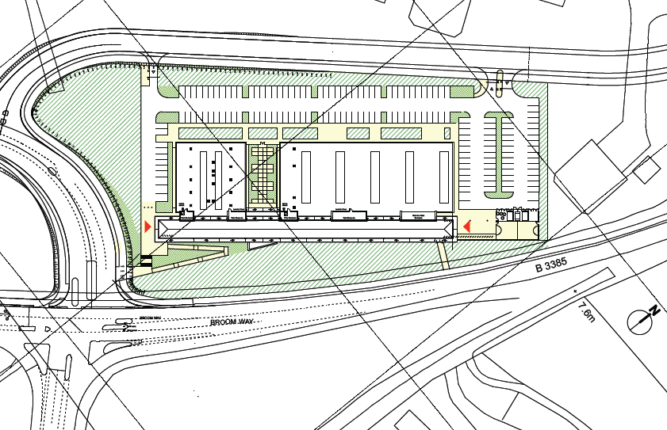

**Appendix 4**

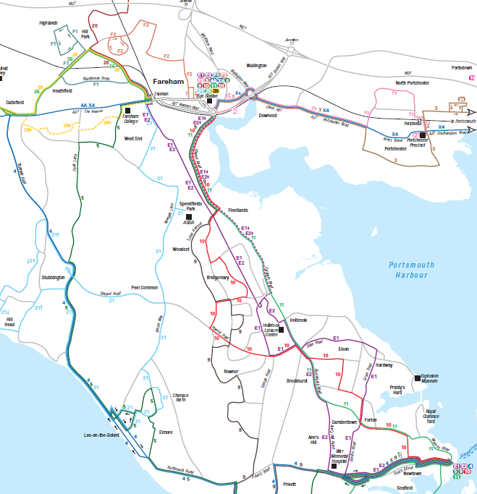

**Appendix 5**

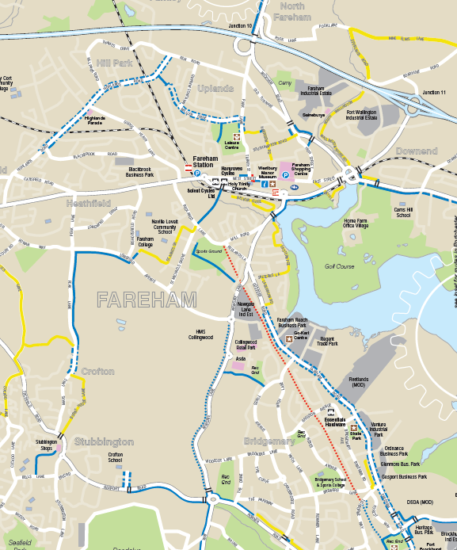

**Appendices 6 and 7 – on separate excel spreadsheets**.

**Appendix 8**

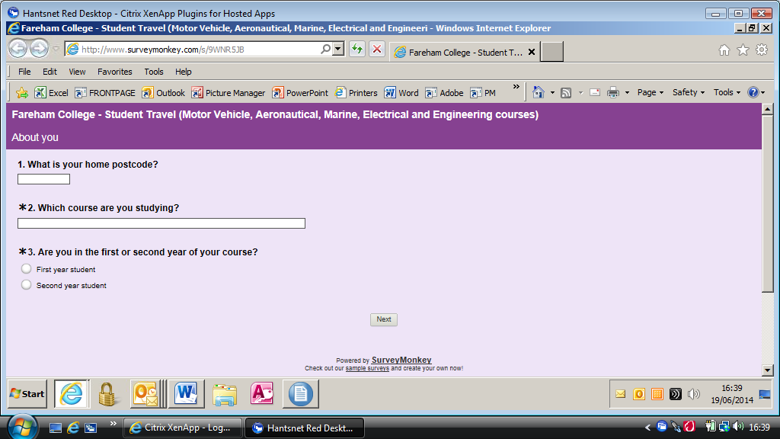

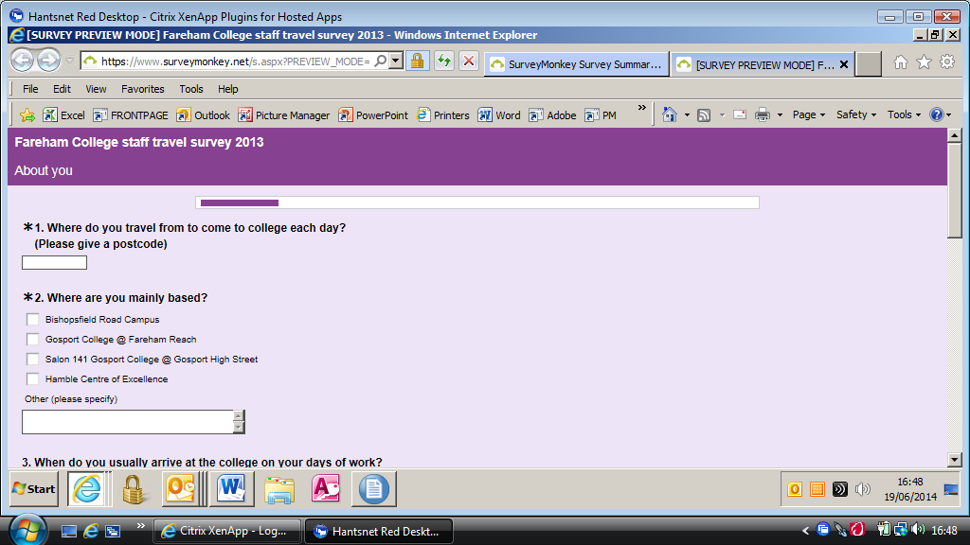

**Appendix 9**

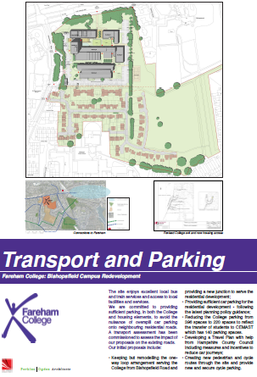

**Appendix 10**

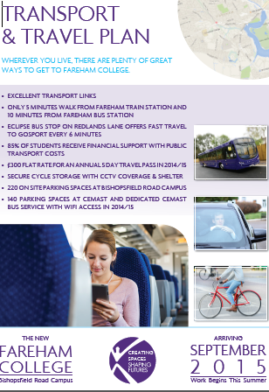

**Appendix 11**

**MEETING OF THE FULL CORPORATION**

**OF FAREHAM COLLEGE**

2 July 2014

**C O N F I D E N T I A L M I N U T E S**

**Present:** Mr K Briscoe

Mr N Duncan

Mr P Grimwood

Mr D Hart (Vice-Chair)

Mr R Kew (Chair)

Mrs J Lancaster

Mr M Mansergh

Mrs N Nageon de Lestang

Miss L Quelch

Miss S Wells

Mr J Westbrook

Ms K Woods

**In attendance:** Mrs J Eayrs (Clerk)

Mrs A Hinton (Executive Director HR)

Mr P Marsh (Deputy Principal

EXTRACT OF DRAFT MINUTES

**46/14 Bishopsfield Road Campus (BRC) Redevelopment Programme Update**

Members of the Board received a confidential paper on the BRC Redevelopment Programme Update and related appendices:

* Appendix 1 – Financial Monitoring Sheet;
* Appendix 2 – First Weekly Internal Newsletter;
* Appendix 3 – Travel Plan.

The Deputy Principal spoke to the paper and drew the following to members’ attention:

1. **Site Sale** - XXXXX
2. **Build Contract and Design Update** – XXX
3. **Loan Financing Update** – XXX
4. **Neighbours and Stakeholder Update** – XXX
5. **William Price Trust Building Works** – XXXX
6. **Travel Plan** – The Deputy Principal presented the Travel Plan and drew the following key points to members’ attention:

* It was a condition of the planning approval for both CEMAST and the main College site that a travel plan be created and implemented;
* The Plan had been shared with the PSG and with colleagues at Hampshire County Council;
* An internal Travel Plan Working Group had been established and the Group had now met in both May and June. In addition, feedback had been received from HCC’s schools travel planning team;
* Originally it had been proposed to introduce an annual charge of £120 for staff to park on the site. As a result of feedback received the charge would now be salary linked;
* There would be no charge for students to apply for a permit to park on the campus;
* The Plan included a number of measures to incentivise greener travel which included:  
  - improved cycle security;  
  - a new scheme to pay staff 20p a mile to cycle to work;  
  - promotion of bus routes and car sharing through websites.
* The Deputy Principal confirmed that the introduction of parking charges on the campus for staff was not intended as an income generation scheme;
* Travel Plan measures would be implemented during the 2014/2015 academic year and would be monitored by Hampshire County Council through further staff and student surveys.

Members of the Board reviewed and discussed the Travel Plan. Concern was expressed at the potential impact on the College’s reputation arising from staff and students parking in the surrounding streets close to the College campus. It was agreed that this was a sensitive community issue which required careful PR management to ensure any potential long-term damage between the College and local residents was avoided.

1. **Costs and Funding** – XXX.

**At the end of the discussion, members of the Board formally undertook the following:**

* **Reviewed and noted the contents of the paper and the current position related to the site sale, the loan financing, the relocation of the nursery, the NHS Leg Care Clinic, the WPCT legal charge documentation and the financial monitoring sheet;**
* **Formally approved the Travel Plan provided at Appendix 3 and delegate to the Deputy Principal authority to make adjustments to the Plan in light of staff consultaion.**